**PIZZA SALES SQL QUERIES**

# A. KPI’S

# 1. Total Revenue:

select sum(Total_price) as Total_Revenue

from pizza_sales;

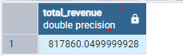

# 2. Average Order Value:

select sum(Total_price)/ count (distinct order_id) as average_order_value

from pizza_sales;

Screenshot 2025-01-23 022703.png

**3. Total Pizzas Sold:**

select sum(quantity) as Total_Pizzas_Sold

from pizza_sales;

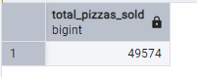

**4. Total_orders:**

select count(distinct order_id) as Total_Orders

from pizza_sales ;

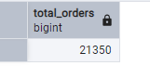

**5. Average pizzas per order:**

select cast(cast(sum(quantity) as decimal(10,2))/cast(count(distinct order_id) as

decimal(10,2)) as decimal(10,2)) as Avg_pizzas_per_order

from pizza_sales

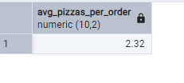

**B. daily Trend For Total Orders**

SELECT TO_CHAR(order_date, 'Day') AS order_day,COUNT(DISTINCT order_id) as total_orders

from pizza_sales

group by TO_CHAR(order_date, 'Day');

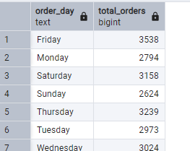

**C. Hourly Trend For Orders**

SELECT EXTRACT(HOUR from order_time) as order_hour ,count(distinct order_id) as total_orders

from pizza_sales

group by order_hour;

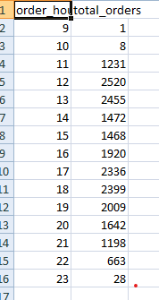

**D. Monthly Trend For Orders**

SELECT to_char(order_date,'month') AS Month_name,COUNT(DISTINCT order_id) as total_orders

from pizza_sales

group by month_name

order by total_orders desc;

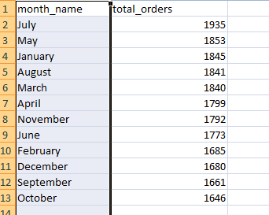

**E. Percentage of Sales by pizza Category**

select pizza_category,cast(sum(total_price) as decimal(10,2)) as total_sales_revenue, cast(sum(total_price) *100/ (select sum(total_price)

from pizza_sales)as decimal(10,2)) as percentage_of_total_sales

from pizza_sales

group by pizza_category

order by percentage_of_total_sales desc;

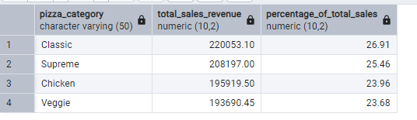

**E. % of Sales by pizza Category in Month of January**

select pizza_category,cast(sum(total_price)as decimal(10,2)) as total_sales, cast(sum(total_price) *100/(select sum(total_price)

from pizza_sales where extract('month' from order_date)=1)as decimal(10,2)) as percentage_of_total_sales

from pizza_sales

where extract('month' from order_date)=1

group by pizza_category;

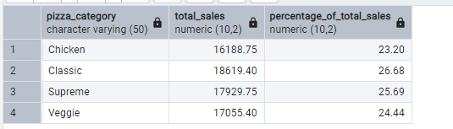

**F. Percentage of Sales by Pizza Size**

select pizza_size,cast(sum(total_price ) as decimal(10,2)) as total_sales,cast(sum(total_price)*100/

(select sum(total_price) from pizza_sales ) as decimal(10,2))Percentage_of_total_sales

from pizza_sales

group by pizza_size

order by pizza_size;

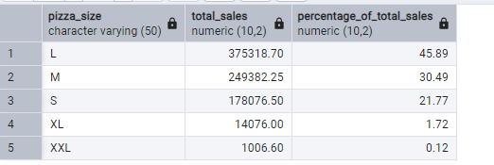

**G. Percentage of Sales by Pizza Size by quarterly_month**

select pizza_size,cast(sum(total_price ) as decimal(10,2)) as total_sales,cast(sum(total_price)*100/

(select sum(total_price) from pizza_sales where extract('quarter' from order_date)=1) as decimal(10,2))Percentage_of_total_sales

from pizza_sales

where extract('quarter' from order_date)=1

group by pizza_size

order by pizza_size;

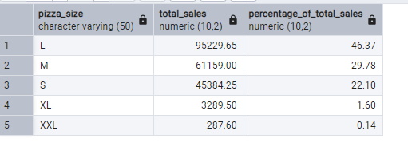

**H. Total Pizzas Sold by Pizza Category**

select pizza_category,sum(quantity) as total_quantity_sold

from pizza_sales

group by pizza_category

order by total_quantity_sold desc

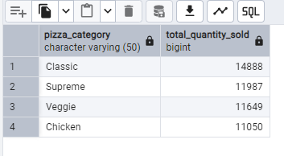

**I. Top 5 Pizzas by Revenue**

select pizza_name,sum(total_price) as total_revenue

from pizza_sales

group by pizza_name

order by total_revenue desc

limit 5;

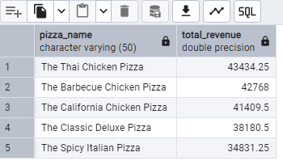

**J. Bottom 5 Pizzas by Revenue**

select pizza_name,sum(total_price) as total_revenue

from pizza_sales

group by pizza_name

order by total_revenue

limit 5;

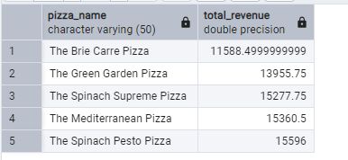

**K. Top 5 Pizzas by Quantity**

select pizza_name,sum(quantity) as total_pizzas_sold

from pizza_sales

group by pizza_name

order by total_pizzas_sold desc

limit 5;

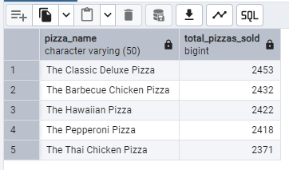

**L. Bottom 5 Pizzas by Quantity**

select pizza_name,sum(quantity) as total_pizzas_sold

from pizza_sales

group by pizza_name

order by total_pizzas_sold

limit 5;

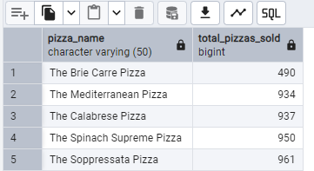

**M. Top 5 Pizzas by Total Orders**

select pizza_name,COUNT(distinct order_id) as total_orders

from pizza_sales

group by pizza_name

order by total_orders desc

limit 5;

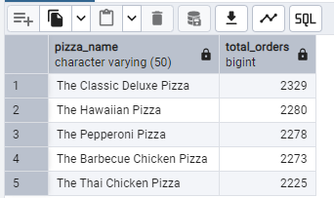

**N. Bottom 5 Pizzas by Total Orders**

select pizza_name,COUNT(distinct order_id) as total_orders

from pizza_sales

group by pizza_name

order by total_orders

limit 5;

